Anne-Marie Graham-Hudak
Canton Township Supervisor
1150 S Canton Center Road
Canton, MI 48188-1699

May 5, 2023
SUBJECT: APPEAL to Canton Township Response to my April 13, 2023 FOIA Requests 23-350
Dear Supervisor Graham-Hudak,
Pursuant to Michigan FOIA guidelines, I am formally submitting an appeal to you for the information requested in my April 13, 2023 FOIA request 23-350.
Please provide the current version of the following files as stored on the Canton Election Management System (EMS) server: (list of log files provided in response to FOIA request 22-857)
The request was complied with in part but the provision of the following files was denied:

- AppPools.txt
- EnabledRules.txt
- FirewallProfile.txt
- InstalledPrograms.txt
- NetConfiguration.txt
- Ports.txt
- Services.txt
- SystemInfo.txt
- UserList.txt
- ListOfSQLInstancesAndDbs.txt
- localhost_Famous Names Acceptance 5 5 Election-2019-02-05-07-47-35_UserLogTable.xml
- localhost_Wayne County 2019 November Election-2019-08-15-11-20-53_UserLogTable.xml
- UserPermissions.xml
- Application.evtx
- EMSSystem.evtx
- EventLogsList.txt
- Security.evtx
- System.evtx

The reason cited for the denial is as follows:
“the disclosure of the records would impact the safety and security of the Township’s voting systems. As a result, that information is exempt from disclosure under Section 13(1)(y). Section 13 (1)(y) permits the Township to exempt records or information of measures designed to protect the security or safety of persons or property or the confidentiality, integrity, or availability of information systems. MCL 15.243(1)(y). The information is also exempt from disclosure because it would disclose procedures, methods, results, organizational information system infrastructure, hardware, or software that would impact the cyber security of the Township. Therefore, it is also exempt under Section 15.243(1)(z).”

Please note that the content for these same file names was issued previously in response to FOIA request 22-857. The only difference in this request is that I am seeking the latest versions of these files.
In response to my denial, I asked the FOIA Coordinator for an explanation for why my request for the current version of the same files that Canton had provided back in August 2022 were not provided in my request nine months later. I repeat this request for an explanation in this appeal. Please provide an explanation for why the current version of the same files provided in August 2022 were not provided in response to FOIA request 23-350.
Short of any substantive reply, I am forced to draw my own conclusions as to why the latest versions of these files have not been provided.
These conclusions are as follows:
- The Canton Township Clerk, Michael Siegrist, has failed to close the firewall ports revealed to be exposed to external intrusions
- The Canton Township Clerk, Michael Siegrist, has failed to remove non-certified software from the Election Management System (EMS) server
The reason for my issuance of a second request for the same records nine months later was to determine whether or not Mr. Siegrist has yet to take actions to mitigate the security risks that were previously brought to his attention. It certainly appears that he has not done so. In fact, the denial of key components of FOIA Request 23-350 certainly indicate that Clerk Siegrist is attempting to cover up the gross negligence and/or malfeasance in the execution of his duties to secure the records under MCL 41.65. The response by members of the Canton Township board to this appeal will determine whether or not they are complicit with this cover up or seek instead to ensure that our election systems are secure from external security threats.
Just to be clear, the principle security vulnerabilities that were discovered as a result of FOIA request 22-857 are twofold.
Vulnerability #1 (See Exhibit A): ALL firewall ports on the Canton Township Election Management System (EMS) Server were configured to be open to bidirectional data transfers as evidenced by this extract from the August 23, 2022 FirewallProfile.txt file. The lack of firewall protection on the server enables anyone interested in subverting the results of our elections access to critical election records such as the vote tallies.
Vulnerability #2 (See Exhibit B): The list of installed programs on the Canton Township Election Management System (EMS) Server per August 23, 2022 InstalledPrograms.txt included software that is not certified for use in U.S. Elections per the Election Assistance Commission. Most concerning amongst this list is the installation of Microsoft SQL Server Management Studio. This program enables anyone interested in subverting the results of our elections to modify the EMS database(s) containing important election records without a trace.
The gross negligence and possible malfeasance of Canton Township Clerk Mike Siegrist exposes the 75,175 registered voters (as of 2020 election) in Canton to fraud. This is not acceptable.
The last time that I attempted to investigate whether or not Canton Township election systems were secure, Clerk Siegrist had the defamatory audacity of accusing me of attempting to subvert the integrity of our elections. This is also not acceptable.
In response to this board’s denial of my previous request, WDIV release a notably biased story on August 26, 2022 that unwittingly revealed that Clerk Siegrist was more than disingenuous in his assertions.
On one hand, Clerk Siegrist seems to suggest that the security configuration of our electronic voting systems is the most important facet of election security. His statement to WDIV in the wake of his denial of my request for access to database records pertinent to the 2020 election was as follows:
“This would be like the largest chink of the armor just removed from the security of the system if this were to go out,” said Siegrist.
On the other hand, Clerk Siegrist attempts to assert in the same story that a simple inspection of ballots is all that is necessary to demonstrate the security of our elections when he said:
“An open records request can be made to come in and visually inspect the ballots,” Siegrist said. “Look at them with the totals unless you want to accuse 300 Canton residents, Democrats, Republicans, Libertarians, Green Party members, U.S. Taxpayer party members of all colluding with each other in one massive conspiracy, but I think canton residents are a little too smart for that.”
Which is it? Do we simply need to look at the ballots or do we need to secure the digital audit trail? It is clear from people who have studied the issue of election security for quite some time that the chain of custody for all election records including digital records is critical. It certainly appears that Clerk Siegrist was attempting to mislead viewers of the WDIV story as to the importance of inspecting ballots as a measure of election security. If that were truly the case, why would he call access to the EMS Server a threat to the “largest chink of the armor” in our election system?
And, for the record, my concerns with the integrity of the elections in Canton is in no way an indictment of the “300 Canton residents” who work on our elections. My concerns are centered squarely on the individual responsible for securing our election records under MCL 41.65. That individual is Clerk Siegrist. It is shameful that he would attempt to extend my concerns regarding the security of our elections to my neighbors in the Canton community.
Clerk Siegrist has had nine months to address critical security vulnerabilities in our Canton Township election system. There is zero evidence that he has taken any responsible measures to secure our elections.
If the Board shares my concern with election integrity, I recommend that they provide the records missing from FOIA request 23-350. I will analyze the records and issue a report to the Board noting any improvements or degradations to the security of our election records under the watch of Clerk Siegrist.
If the Board refuses to comply with my request for the missing files, I respectfully request that Board members perform their own investigation of the security of our electronic voting systems and issue a report to the members of our community at least 90 days prior to our next election that provides evidence of substantive actions taken to address the security concerns that I have raised. This evidence should include as a minimum the release of firewall profiles showing that the majority of ports have been blocked and that the software installed on the Canton EMS Server is limited to the applications certified by the Election Assistance Commission.
Until proven otherwise, please note that the Canton Township Board presides over an election infrastructure that features significant security vulnerabilities. Failure to act to resolve these vulnerabilities would be a disservice to the members of our community who put their trust in you to secure our rights. I am more than willing to assist you in this pursuit. The most expedient manner of doing so would be for you to provide the missing files in your response to FOIA Request 23-350.
The requested files can be submitted via an email providing download instructions to patrick@migrassrootsalliance.org or I am willing to provide a flash drive to which you can download the files. The flash drive can be mailed to the address below.
In contrast to the handling of my previous appeal in which I was not afforded the opportunity to respond to any assertions made by Clerk Siegrist prior to the vote, please provide me with at least 24 hours notice of your intent to deliberate on this appeal at one of your public board meetings. If my schedule allows, I will attend to defend my appeal.
If you choose not to provide the requested information, you are hereby given notice of the need to preserve these records until a court rules on this matter.
Thank you for your prompt attention to this matter.
Regards,

Patrick J. Colbeck
President, MI Grassroots Alliance
Former MI State Senator, 7th District
47841 Royal Pointe Drive
Canton, MI 48187

Attachments:
- May 3, 2023 Canton Township FOIA Coordinator response to FOIA Request 23-350
- Exhibit A: Segment of August 23, 2022 FirewallProfile.txt provided per FOIA Request 22-857
- Exhibit B: Segment of August 23, 2022 InstalledPrograms.txt file provided per FOIA Request 22-857

Dear Patrick,

Canton Township received your Freedom of information Act (“FOIA”) request for:
“the following files as stored on the Canton Election Management System (EMS) server:

· Error.log
· Info.log
· Error.log
· Info.log
· Trace.log
· Error.log
· Info.log
· Trace.log
· Error.log
· Info.0.log
· Info.log
· Trace.log
· Error.log
· Info.log
· Trace.log
· AppPools.txt
· EnabledRules.txt
· FirewallProfile.txt
· InstalledPrograms.txt
· NetConfiguration.txt
· Ports.txt
· Services.txt
· SystemInfo.txt
· UserList.txt
· ListOfSQLInstancesAndDbs.txt
· localhost_Famous Names Acceptance 5 5 Election-2019-02-05-07-47-35_UserLogTable.xml
· localhost_Wayne County 2019 November Election-2019-08-15-11-20-53_UserLogTable.xml
· UserPermissions.xml
· Error.0.log
· Error.log
· Warn.log
· Info.0.log
· Info.1.log
· Info.10.log
· Info.11.log
· Info.12.log
· Info.13.log
· Info.14.log
· Info.2.log
· Info.3.log
· Info.4.log
· Info.5.log
· Info.6.log
· Info.7.log
· Info.8.log
· Info.9.log
· Info.log
· Debug.log
· Info.log
· Warn.log
· Application.evtx
· DVSAdjudication.evtx
· EMSSystem.evtx
· EventLogsList.txt
· Security.evtx
· System.evtx
· Warn.log

Your request has been granted in part and denied in part.

Parts Granted and emailed:
Info.log
EventLogsList.txt
DVSAdjudication.evtx
Trace.log
Error.log
Warn.log
Debug.log

The Township denied parts of the request because upon further review of the documents requested, the Township has determined that a portion for the request should be denied because
the disclosure of the records would impact the safety and security of the Township’s voting systems. As a result, that information is exempt from disclosure under Section 13(1)(y). Section 13 (1)(y) permits the Township to exempt records or information of measures designed to protect the security or safety of persons or property or the confidentiality, integrity, or availability of information systems. MCL 15.243(1)(y). The information is also exempt from disclosure because it would disclose procedures, methods, results, organizational information system infrastructure, hardware, or software that would impact the cyber security of the Township. Therefore, it is also exempt under Section 15.243(1)(z).

Since your request has been denied you have the right to (1) submit to the head of the public body a written appeal that specifically states the word “appeal” and identifies the reason or reasons for the reversal of the disclosure denial or (2) seek judicial review of this decision, as stated in Section 10 of the Michigan Freedom of Information Act, MCL 15.240. Further, you have the right to seek attorney fees as provided in Section 10 if the court determines that the Township has not complied with this Section and orders disclosure of all or part of the public record.

Canton Township’s FOIA Procedures and Guidelines Public Summary are available at the following website, as well as information about your right to appeal: https://cantontownshipmi.nextrequest.com/

Should you have any questions, please feel free to contact me.

Sincerely,

FOIA Coordinator

Exhibit A: Segment of August 23, 2022 FirewallProfile.txt provided per FOIA Request 22-857

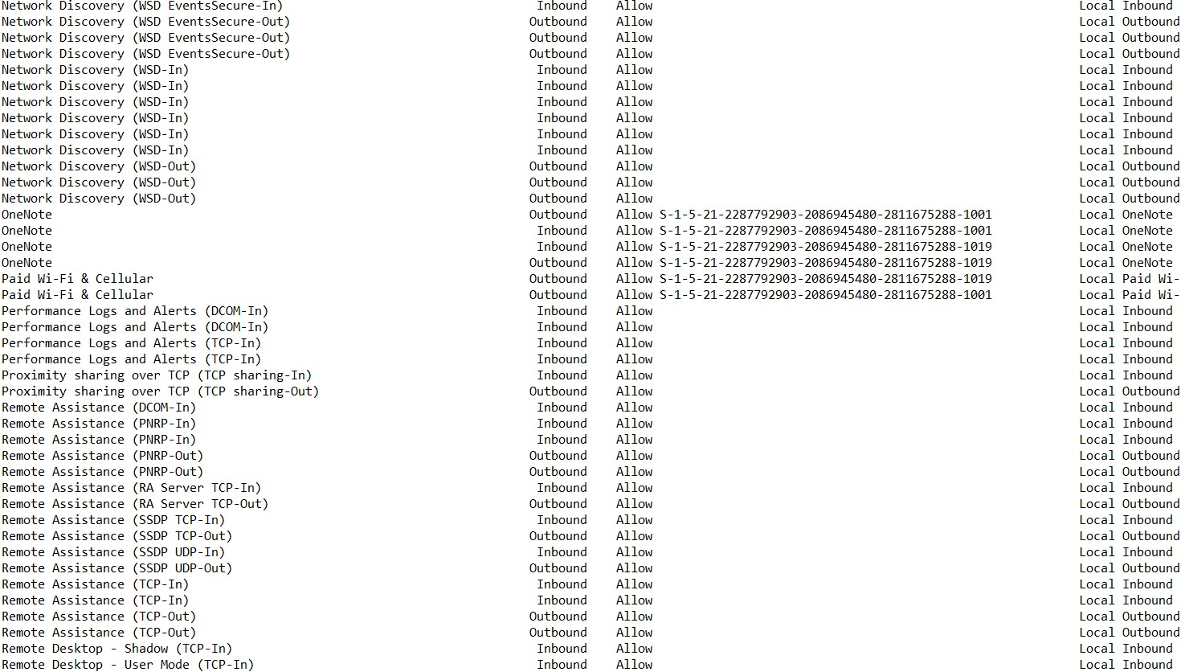

Exhibit B: Segment of August 23, 2022 InstalledPrograms.txt file provided per FOIA Request 22-857

